Exam 3

Answer the following questions. Most of the questions are open ended and the answer may not be unique. Do not answer with a single word for most of the questions and provide as many details as possible.

1. The following treemap is about the 2012 United States Presidential election.  
  
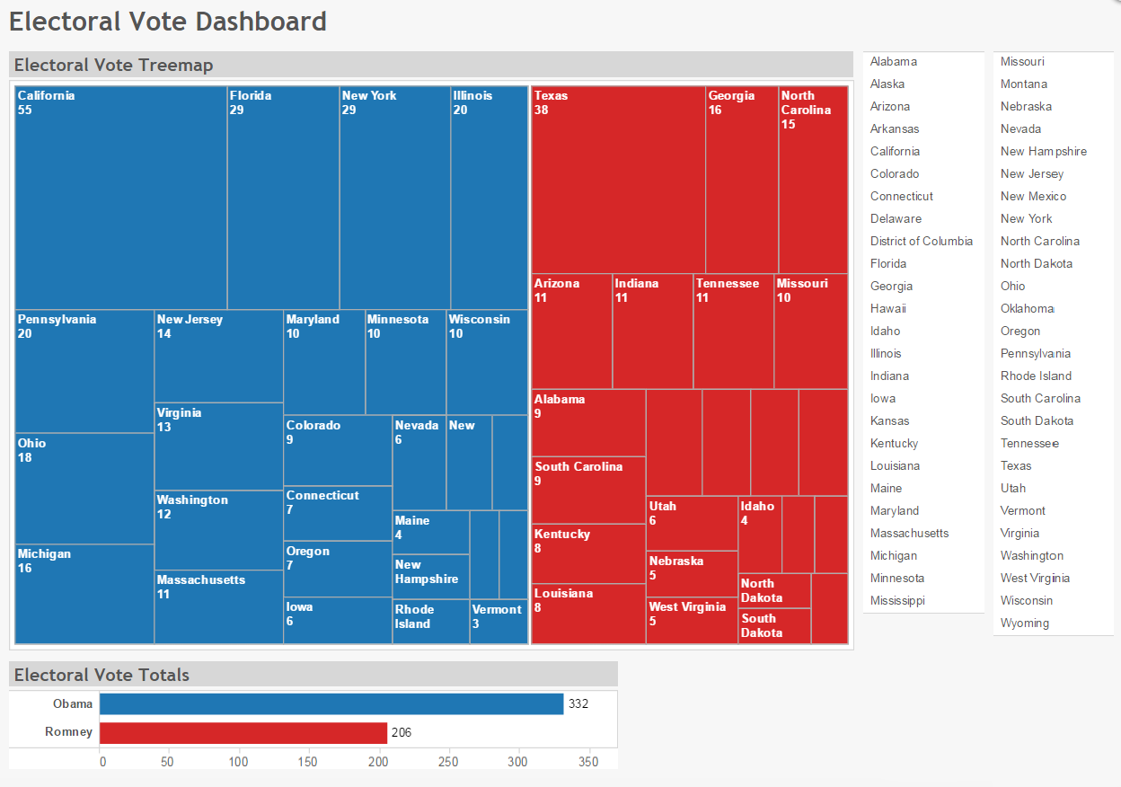  
  
a. Determine if this is a good or bad treemap? Explain why.  
b. Is there anything about it that you can criticize?  
c. If you want to augment the data set with the popular vote, how would you represent the popular vote   
 on the same treemap?  
d. What do you think about the color choice? Is it CVD friendly?

2. The following treemap is about the stock market.  
  
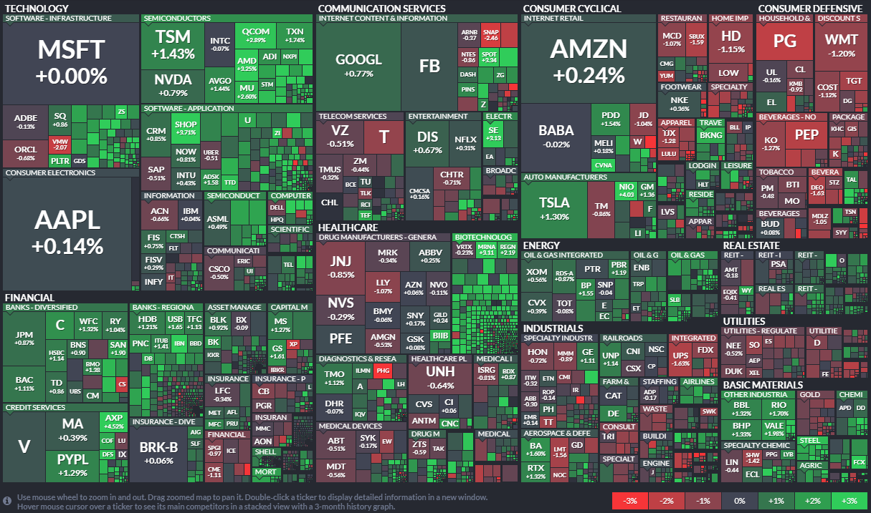  
  
a. Determine if this is a good or bad treemap? Explain why.  
b. Is there anything about it you can criticize?  
c. How can you enhance it?  
d. In addition to companies, Industries have a color associated with them as well, what does that color   
 represent and how is that helpful?  
e. If we added one more level either to the top or bottom of the hierarchy, do you think the treemap   
 would still be efficient in representing the data? Consider different scenarios and justify your answer.

3. The following treemap is about the world oil consumption. The number represents the number of oil   
 barrels each county consumed per day.  
  
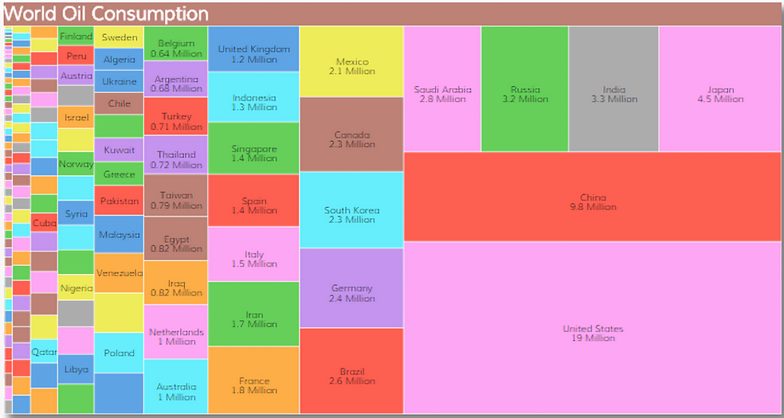  
  
a. Determine if this is a good or bad treemap? Explain why.  
b. What changes would you make to enhance the treemap?

4. Which structures of trees can efficiently be visualized by a treemap? And which structures do not   
 result in an effective visualization? Please draw some example trees for each case.  
 (hint: you can talk about the depth of the tree and balance of the nodes and weights.)

5. What are the drawbacks of standard treemaps that we discussed in class? Can you think of more   
 drawbacks?

6. Look at these charts about Hong Kong’s population in four different years and come up with at least   
 three findings based on them.  
  
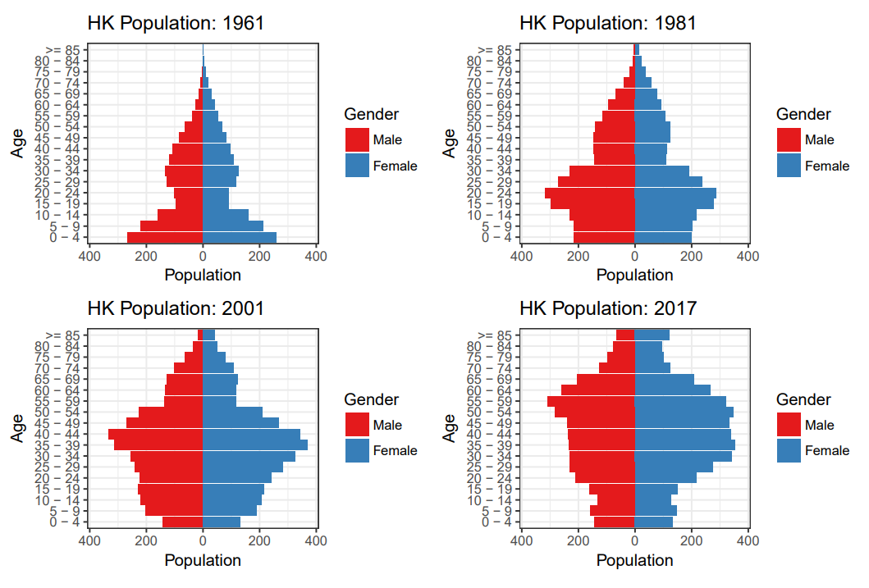

7. If we have a balanced tree, as in the image below, would you prefer to use a treemap or a sunburst   
 chart? Justify your answer.  
  
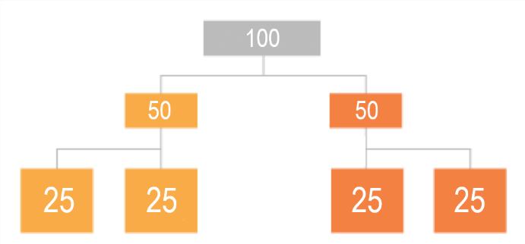

8. Suppose you are given some data about the following 8 cities: Budapest, Chicago, Dublin, London,   
 Munich, New York, Paris, and Rome. Which of the following options would you use to visualize that   
 data? And why would you choose that one over the others? If we increase the number of cites to 100,   
 would you still choose the same option?  
  
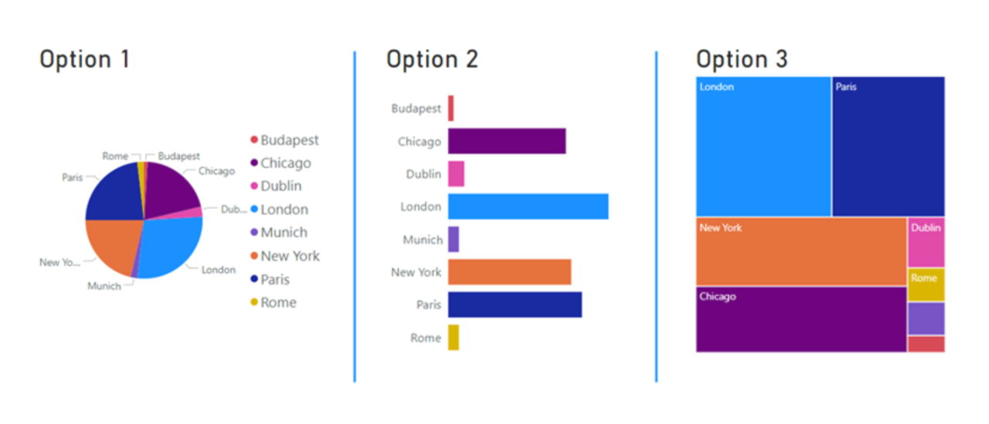  
  
  
  
  
  
  
  
  
  
  
  
  
  
  
  
  
  
  
  
  
  
  
  
  
  
9. Consider the following treemap and sunburst chart based on the same dataset that consists of  
 population of the US regions and median household income in those regions.  
  
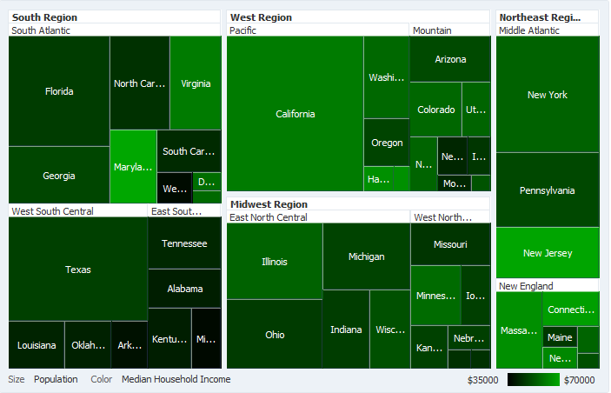  
  
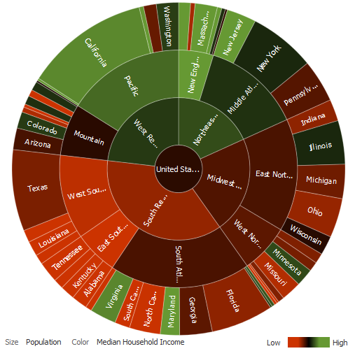  
  
a. Describe the coloring scheme for each of these charts.  
b. Which chart provides more information about the inner nodes of the hierarchy?  
c. If we want to add one more level to the bottom of the hierarchy, which chart can accommodate that  
 level in a suitable fashion for navigating hierarchical structure of the data?

10. Consider the following bar chart and pie chart based on the number of sales made from some fruit in a fruit stand.  
  
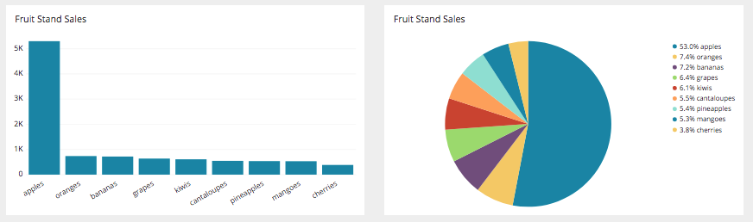  
  
a. Which one would you use and why?  
b. What unique insight can you gather from this specific pie chart that cannot be gathered from the bar chart?

Submission Format:

* Submit the pdf file on Canvas Exam 3 page.
* Name the pdf as: GroupNumber-LastNamesOfYourTeamMembers-Exam3.pdf
* Only **ONE** submission per group is needed.